School Prospectus

for

Dudley Infant School

All Aboard …..


Governors
Staff
Pupils
Parents
Visitors
Be prepared

Keep going …

Go for goals!

….. the ship of learning
Dudley
A rising tide lifts all ships!

November 2012

Harold Road, Hastings
East Sussex. TN35 5NJ
01424-422981
e-mail: office@dudley.e-sussex.sch.uk
web site: www.dudley.e-sussex.sch.uk

Headteacher: Mrs Joanne McCarron-Charles
Chair of Governing Body: Mr William Hamilton

CONTENTS

 | Page No.
Introduction | 3
Buildings and Grounds | 3
School Dinners | 5
Philosophy | 7
Equal Opportunities | 8
Children with Additional Needs | 8
Gifted and Talented | 8
Pastoral Care | 8
Communication with Parents | 9
Class Organisation | 9
Curriculum Organisation | 9 – 11
Assessment | 11
Freedom of Information | 12
Collective Worship | 12
School Uniform | 12
Attendance | 13
Absence Procedures | 13
Extended School Provision | 13
Charging Policy | 14
The Next Stage | 14
Admissions Criteria | 14
School Terms and Holiday Dates 2011-2012 | 15

Introduction

Dudley Infant School is a County Primary school for children aged 4+ - 7+ and has approximately 180 on roll. The information given in this prospectus is intended for parents who are considering their child’s entry into school in 2013. It is correct in relation to November 2012, and includes, as far as possible, any changes planned by the school for September 2013. However, it must not be assumed that there will be no changes before the start of, or during, the school year beginning September 2013, or in relation to the following school years.

Parents who would like to discuss any aspects of the school with the Head teacher are invited to make an appointment to visit the school by speaking to the school Administers. Please telephone in advance to book a visit.

Buildings and Grounds

The school was built in 1913 with a classroom added in the 1950’s. A demountable unit was installed in 1989.

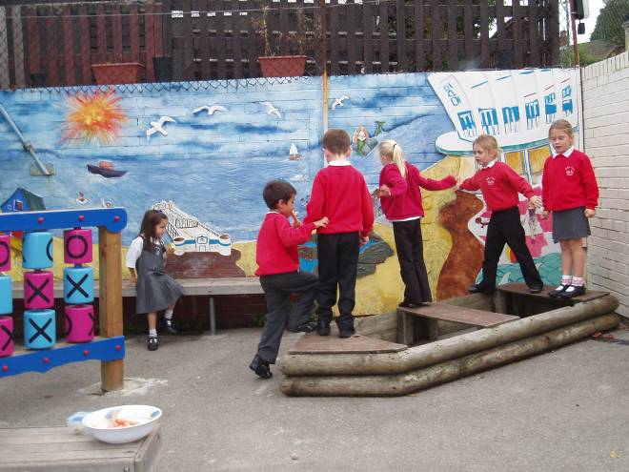

The grounds are varied, with a playground area and adventure garden areas to the rear of the buildings

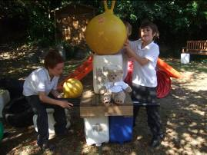 | 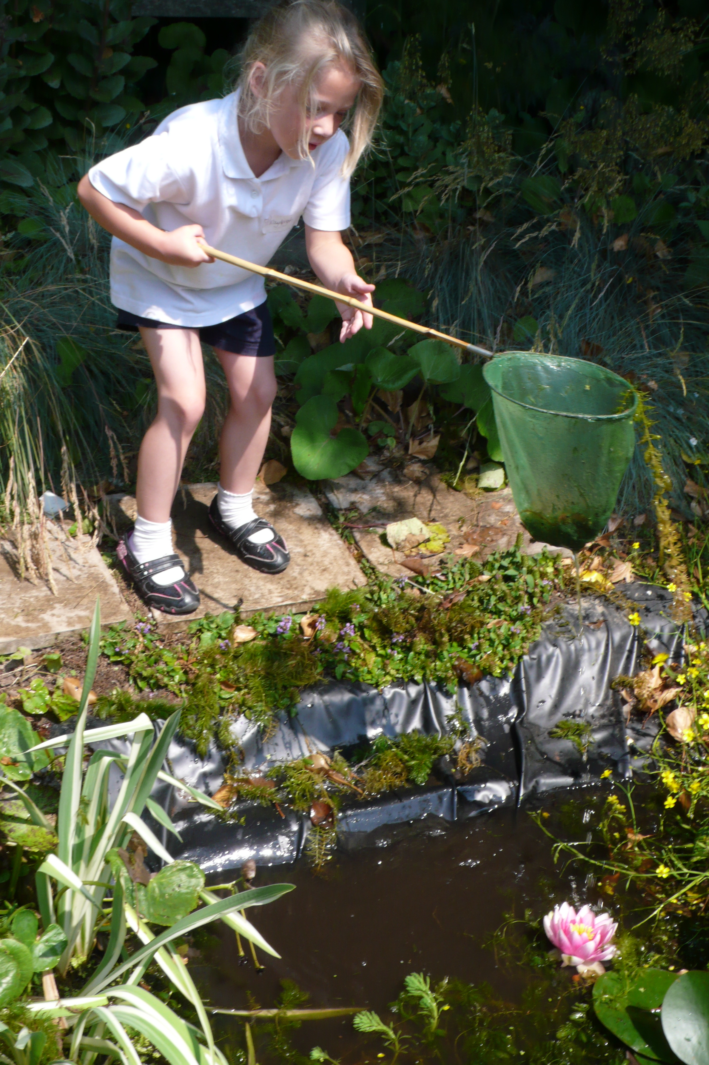

The adjoining playing field of Sacred Heart School is available for use at lunchtimes and for P.E. when the weather is suitable.

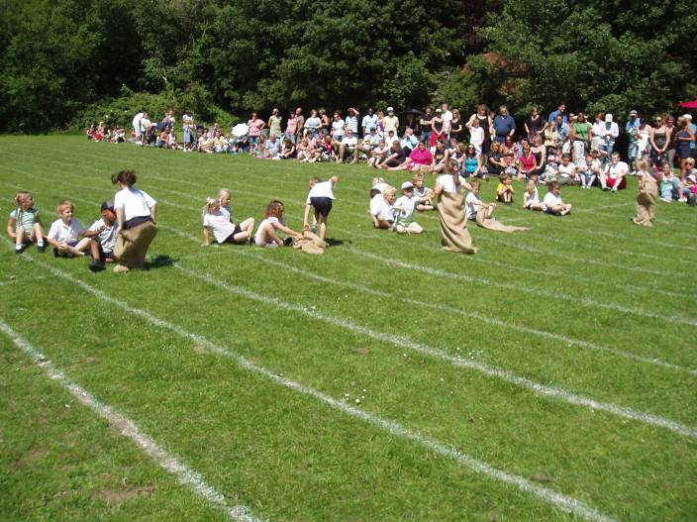

The main building has 4 classrooms, a library with videoconferencing equipment, offices and hall. The hall is equipped with a multi media system and P.E. apparatus and serves as a gym, a dining hall and is used daily for assemblies. Cloakroom and toilet facilities are conveniently located at each end of the school. The main corridor houses the reading scheme books and specialist shared equipment. The Reception class is based in a demountable unit which includes a specialised role play area but will be replaced in April 2013 by two new purpose built classrooms.

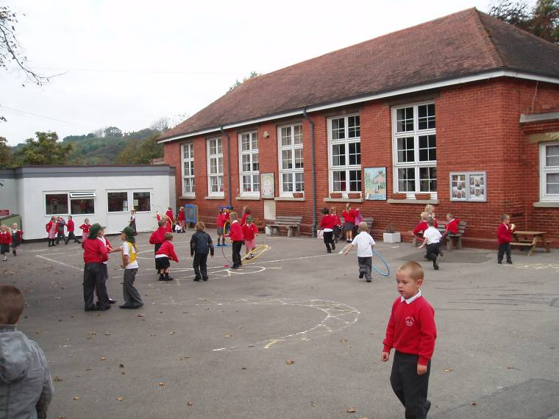

During the summer of 2010 a purpose built internal area was designed to provide additional space for children and adults which is quiet, clean, bright and stimulating. This room, which we refer to as the “Snug” is used by staff and outside agencies to deliver programs which are tailored to personalised learning and promote emotional well-being and positive social skills to small groups. It is also timetabled for our school nurse and governors to offer advice “surgeries” to parents and offers space for adult educational sessions.

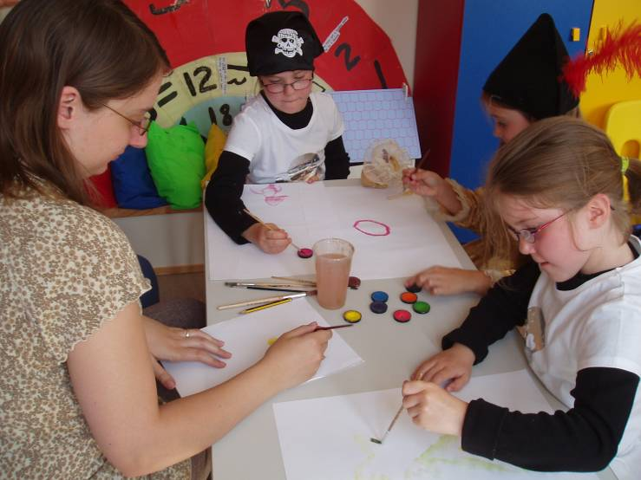

The majority of children bring packed lunches to school but school meals are available and are prepared in the servery through E-Steam, a technology which steams flash-chilled fresh food. The school gained an upgraded Silver Healthy Schools Award in March, 2007. Please note Dudley is a nut-free zone because of children with severe allergies. We do not allow peanut butter or other nut products in lunchboxes or as snacks.

We make very good use of the accommodation at Dudley Infants. The school is kept clean and is treated with respect by the pupils. A large-scale train and ship in the playground are popular areas for the pupils to use their imagination, and benches provide suitable quiet areas during playtimes. The woodland garden and landscaped pond area provide rich resources for science, environmental studies and recording weather and temperatures.

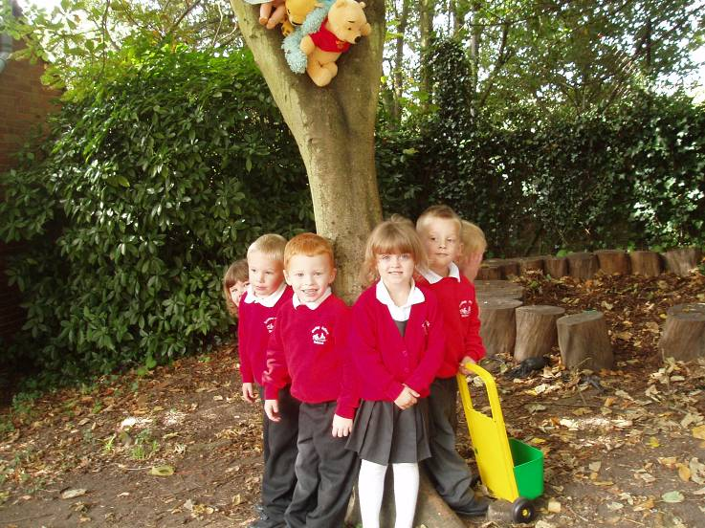

There is a scheme in school to provide free fruit for all the children and milk for under fives. Milk for over fives can be ordered on-line from the supplier.

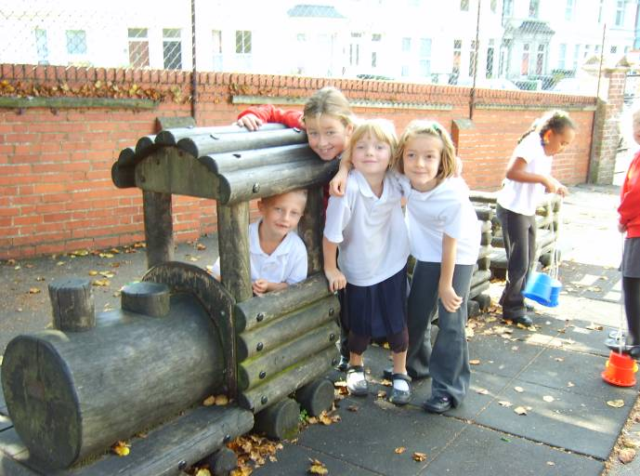

The train is an exciting feature on the playground and always draws a crowd.

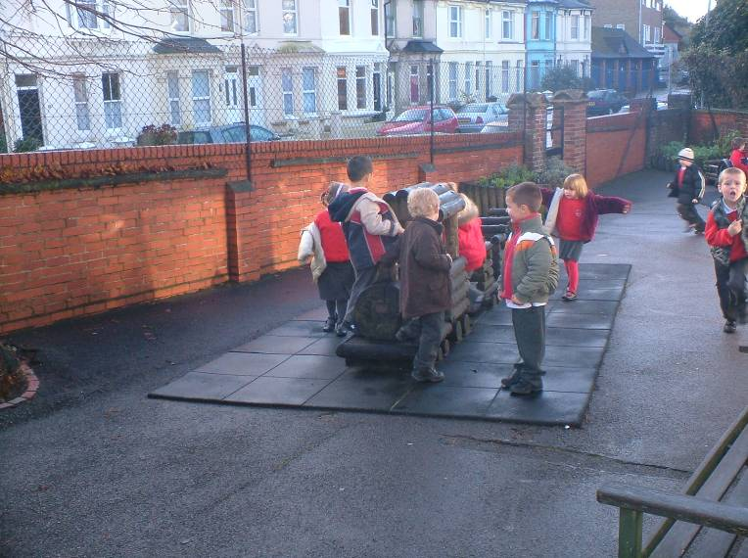
The Vision for Dudley Infant School

“Prepared to learn”

At Dudley we…

Provide support and security, creativity and challenge, encouragement and enjoyment.
Respect and celebrate individuality and others’ beliefs.
Expect high standards in teaching, learning and behaviour.
Promote independence, collaboration and consideration for others.
Aim for excellence.
Remember it is fun.
Encourage positive attitudes.
Dudley- prepared to learn

“High quality day-to-day care is aided by strong links with outside agencies and kind and helpful guidance from all staff, including teaching assistants.” (2010 Ofsted report)

Our Shared Philosophy
Every child is unique and individuality must be encouraged and valued. The way in which children learn best needs to be reflected in our curriculum framework and planned environment. The infant years cover an important period of change and development in children’s thinking and in their ability to make sense of the world. Young children learn through experience that is most effective when relevant and active within a challenging and familiar context.

”Well-established links with the local community are a particular strength of the school and the school does well to involve all groups of parents in the life of the school, especially those who may not have had good experiences of school life themselves.” (2010 Ofsted report)

Equal Opportunities
Within all aspects of education at Dudley Infant School, we take positive action to ensure that the needs of all pupils and staff are being met in a fair way, irrespective of gender, ethnic origin, disability, specific ability or social background. The Education Act (1988) directs that all children have an entitlement to a broad and balanced curriculum. This means that the curriculum that we provide is one in which equal access for all is the starting point. We aim to identify and support all children prone to Dyslexia following the guidance laid out in the East Sussex Dyslexia Policy.

Children with Additional Educational Needs
Our aims as laid out in “The Vision for Dudley Infant School” are intended for all the children, including those pupils who have additional needs, as we value all the children in our school equally and we endeavour to be aware of every child’s individual needs.
Wherever possible, the child with Additional Education Needs will be accommodated within the school environment. However, it may be necessary, from time to time, to make special provisions. These will be monitored closely. Children with Additional Educational Needs are supported in the classroom by learning support assistants. This support can be on a one to one level or in a group situation. The child’s progress is monitored carefully and discussed regularly with parents. Parents of the children with Additional Educational Needs are always welcome to discuss their child's progress with the class teacher and Miss Waterhouse, the school's Inclusion Manager.
Miss Waterhouse is responsible for ensuring delivery of the best possible provision for children with additional needs and works in partnership with the Head teacher, Management Team and teaching staff. The team at Dudley Infant School is proud of its record in helping all children to realise their potential.

“Staff are very effective in helping vulnerable children, for example through nurture groups.”
“One parent aptly said: ‘Individual needs are addressed in an environment that is nurturing, stimulating and extremely positive.’
“Strengths include the way in which leaders have actively developed provision for
pupils with special educational needs and/or disabilities and to help boys to do
better.” (2010 Ofsted report)

Gifted and Talented
At Dudley we recognise that able, gifted and talented children may have specialist needs. We aim to provide opportunities for these needs to be met in the classroom Special events or enrichment activities are also organised to specifically meet their needs. These events and activities can be school based in school time, but also in other schools or venues. In previous years we have organised artists and dancers to work with children, creative writing clubs and maths challenge workshops.

Pastoral Care
Each child is in the care of the class teacher and it is to her that the child will usually bring his or her anxieties. However, the children are encouraged to regard all staff, including the Head teacher, as available to them if the need arises.

Parents should be aware that the school will take any reasonable action to ensure the safety of its pupils. In cases where the school has reason to be concerned that a child may be subject to ill treatment, neglect or other forms of abuse, staff have a legal responsibility to follow the East Sussex Protection Procedures and inform the Social Services Department of their concerns.

Our aim is to develop and nurture a positive self-image and a sense of self-discipline in our children. We believe in good and considerate behaviour that will respect others and an orderly school community in which effective learning can take place. If there is cause for concern, parents are immediately involved. Rewards in the form of a ‘Dudley Smile’ are presented at the special assembly on Friday afternoons when the whole school celebrates academic and general achievement.

Communication with Parents
Parents are encouraged to be actively involved in their child’s learning and the life of the school. The home reading scheme expects parents to read daily with their children and be constantly up to date with progress. Parents are invited into school to view any aspect of their child’s education. From September 1999 Home School Agreements (a contract between parents and school) have been in place.

Dudley has a very supportive Parents Association known as “Parents of Dudley” (POD). All parents are very welcome and encouraged to be involved with their activities which provide an exciting social network as well as funding for quality experiences for the children.

Regular opportunities are provided for parents to discuss their child’s progress with the class teacher, but an appointment can always be made to discuss any issues with the teacher or Head teacher as the need arises. The Management Team is committed to an open and honest exchange of ideas, and to that end, endeavours to be highly visible on the playground at the beginning and end of the school day to address any concerns that may arise. A weekly newsletter is printed on Fridays to ensure that the entire school community is up to date with events both in school and in the local community. Parents are invited to contribute to the newsletter if their item will be of benefit to other parents or the children.

We greatly value support given by parents, many of whom help by participating in the activities of the classroom alongside the teacher. The input from an extra adult with the children always proves beneficial. Parents also help with accompanying trips out of school and supporting fund-raising activities.

“Parents whole-heartedly agree that their children enjoy school, are well cared for and that their children’s particular needs are well met. The inspectors agree with this view as children are happy, polite and behave well. Almost every parent also agrees that their children are making progress. Relationships are very good and parents and inspectors agree that staff are supportive and approachable. The views of one parent sum up those of many when saying, ‘The school really values parents as partners and puts great effort into caring for and educating our children.’ Parents like the way that they are helped to support their children’s learning. They spoke highly about the very good transition arrangements with the junior school and the helpful home visits for children when they start in the Reception class. Inspectors confirm that these are especially successful in helping children to settle happily into their new schools.” (Ofsted report 2010)

Class Organisation
Dudley Infant School has a two-form intake of 60 children in each year group. Classes are organised into year groups; there being two classes for each year group.

Our Creative Curriculum

At Dudley we are proud of our highly creative curriculum, which draws together many of the aspects of other areas into a series of exciting topics covered through Learning Adventures. The Learning Adventures are designed to engage and motivate the children in their own learning. As the children progress through the topics they are able to build on and develop a diverse and important range of skills. This ‘whole learning’ approach enables children to apply their skills and transfer their knowledge from one subject to another. It also helps children to make connections and join up their thinking. Most importantly, it increases children’s confidence, interest, motivation and learning.

Our Dudley Vision is embedded throughout our curriculum to provide every child with:
- A broad and balanced education, covering all aspects of the National Curriculum, as well as important issues such as health, safety, personal and social development and an understanding of their community.
- The opportunity to develop skills and acquire understanding which provide a firm foundation for all future learning.
- An environment that offers equal opportunities for all, regardless of gender, race, social background or physical ability, and encourage children to develop self-confidence.
- A positive learning experience
“Very close collaboration with the nearby junior school helps to assure progression in learning for the pupils. The school makes very effective use of the local community and the area’s rich history to enhance pupils’ learning. Members of the local artists’ community are invited to share their work with the pupils and a specialist music teacher takes lessons throughout the school.” (2007 Ofsted Report)

The Early Years Foundation Stage / Reception Classes

Our aim at Dudley Infant School is to create a stimulating and caring environment that develops the fundamental characteristics of learning in all our pupils.

The characteristics of effective learning

1 Playing and Exploring
2 Being Creative and Thinking Critically
3 Active Learning

These characteristics begin to develop from birth as children relate to their environment and the people in it.
The many ways in which a child engages with both environment and people underpin learning and development across the prime and specific areas found in the Early Years Foundation Stage curriculum.

The Prime Areas

- Personal, Social and Emotional Development
- Communication and Language
- Physical Development

The Specific Areas

- Literacy
- Mathematics
- Understanding the World
- Expressive Arts and Design

At Dudley, the EYFS team are dedicated to working together to plan children's learning experiences and monitor their progress towards the Early Learning Goals.
These early Learning Goals state what is expected most children will achieve by the time they move on to Year One.
As children progress through the Reception Year the level of teacher led focus activities gradually increases although learning through play still remains central.
We offer a variety of play provision including sand, water, role play, construction, play dough, painting and other art activities. Outdoor play is provided in both the playground and our landscaped purpose-built garden.
Your child will also be able to access laptops and computers, practise writing, share and enjoy books and get involved in activities in the maths area.

Maths

Our principle aim is to develop a positive attitude towards mathematics in our pupils. Using direct experiences in a wide range of contexts throughout the curriculum, pupils are given opportunities to appreciate the relevance mathematics has to the real world. Through these experiences children learn the basic mathematical concepts as well as developing strategies such as reasoning, logical thinking and making and testing hypotheses.
In the Foundation Stage (reception class) mathematical development is taught through three key strands, numbers for labels and counting, calculating and shape, space and measure. In Key Stage 1 (Years 1 and 2) The Primary Numeracy Framework is followed which provides five units of work covering Counting, Calculating, Shape, Handling data and Measuring. The units are enriched by investigational work, problem solving, and the use of computers. More emphasis is given to the development of mental calculation skills which can give children confidence to work in all areas of the subject.

Literacy

Literacy focuses on developing each child’s ability to understand and use language as an integral part of learning, in all areas in order to interact effectively with the world around them, to express themselves creatively and to communicate confidently using a variety of skills and media. Literacy is therefore a key to learning as well as a key to enjoyment and personal growth.
At Dudley, Teachers enable pupils to develop knowledge, understanding and skills in a wide range of areas such as: Speaking & Listening and Reading & Writing. In KS1, we teach daily Literacy sessions following the Primary Literacy Framework where children explore different units such as Traditional Tales, Poetry, Fantasy setting stories and other Non-Fiction writing topics. Reading is taught using the 'Letters and Sounds' which is a synthetic phonics programme. This is introduced in reception and carried on throughout KS1. Regular opportunities are given to children across the curriculum to blend and segment the sounds. At Dudley, we aim to enable children to become confident, independent readers who understand that books of all kinds are a source of pleasure and information. Written work is encouraged for a variety of purposes, and we give full emphasis to basic skills such as spelling, handwriting and punctuation. The school has a well-resourced library and all children are encouraged to make the most of this.

Science

Our science area of the curriculum is covered through topic work in a way which is meaningful for the children. Wherever possible, we offer children first hand experiences through activities which are varied and stimulating so as to extend the children’s natural curiosity and creativity.

Children are innately curious about themselves and the world, and the teaching of science enables this natural inquisitiveness to be channelled to help them make sense of the world in which we live. As science links practical experiences with ideas, it can engage children of all abilities and experience. It enables them to ask questions, plan logically, think critically and improve their own learning. We want to prepare children for their life in an ever increasingly scientific and technological world.

At Dudley science is FUN and we are excited by moments of awe and wonder ….rushing outside to catch the first fall of snowflakes, watching butterflies emerge from their cocoons, experiencing making charcoal after using all of our senses around a bonfire or stopping to watch a spider spin a web.

ICT
Information and Communication Technology (ICT) is prevalent in all areas of our society. Therefore, at Dudley, we recognise the importance of ICT as both a stand-alone subject as well as a tool to support enthusiastic learning across all areas of the curriculum.
Each classroom has an ICT zone, resourced with a number of laptops to ensure children can access both key educational software as well as targeted learning through the internet. We are also equipped with a bank of laptops which allows for whole class teaching of ICT skills and, again, to support and consolidate learning in all areas. We are also using ICT to extend learning into the home with the introduction of bug club and the school’s learning platform where many extra curriculum resources can be accessed in a fun and exciting way.

Humanities

History and Geography often form the focus of half-termly topics taught through Learning Adventures in Year One and Year Two. Through Literacy, for example, children will learn and write about Medieval London and the Great Fire. They will also learn about the Victorian Era through a topic which we hope will embrace and celebrate our school’s centenary this year.

This “whole learning” approach enables children to discover aspects of history and geography in a purposeful way and allows them to apply the skills they have learnt in other areas of the curriculum.

Hastings and its surroundings provide rich learning opportunities for both subjects. Whenever possible, teachers take advantage of the history and geographical features of this famous sea-side town to plan exciting first-hand learning experiences. Geography studies begin with an exploration of our school grounds and then widen to the local area to include Alexandra Park, the nearby beach, as well as the East and West Hills that surround the Old Town of Hastings. Studies widen still to include an exciting topic on Rain Forests from around the world.

Dudley Infants is currently developing a global link with a school in Sierra Leone. We hope that this link will go a long way to extend our pupils’ knowledge of the world at large and will enable them to learn about and appreciate cultural differences in a country so different from their own. Children will also enjoy learning about different countries and their cultures when we celebrate Multicultural Week later this year.

Art and design

In the foundation stage, we offer the children a range of creative activities and materials to experiment. We encourage careful observation of the world around us and development of the imagination in the children’s mark-making. Children are taught how to make joins in order to make choices about the best ways to make models and collages in 2d and 3d.

These skills are developed in key stage 1 where children continue to use colour, shape, pattern and texture in a more skilful way exploring their ideas and encouraging self-evaluation of their work. Looking at the work of famous artists and developing expression of personal taste and a critical eye is introduced. Wherever possible, we include the expertise of local artists to talk to and work with the children. Last year we had an artist in residence and this year we look forward to working collaboratively with the Jerwood Gallery.

Music

At Dudley we strive to inspire children to develop their own enjoyment of music.
They are given ample opportunity to listen, create, play, respond with movement, perform and enjoy a wide range of music.

The children participate in class and whole school singing and enjoy playing our great selection of classroom percussion instruments.

They perform in school productions and end of term services. There is also the opportunity to learn the violin through the East Sussex Music Service. Music is embedded in the school curriculum and as well as classroom musical and singing activities, the children have a weekly music lesson taught by a specialist teacher

Physical Education (P.E.)

Through P.E. children begin to develop spacial awareness and team play using a variety of indoor games, dance and gymnastics sessions. Opportunities for dance performances are incorporated into class lessons with links to Learning Adventures where applicable.

Outdoor P.E. lessons focus on balls skills, developing their gross and fine motor skills as they refine skills learnt in reception. More specific skills including bouncing, kicking and catching using larger balls (i.e. football, basketball) are developed over the two years in KS1. The summer term further develops athletics and game play using modified team activities.

Personal Health and Social Education (PSHE)

The broad aim of Personal, Health and Social Education is to help children understand and value themselves as individuals and as responsible, caring members of the school and wider community in which they live. The school policy addresses the areas of Health Education, including Sex Education, Drugs Education, Equal Opportunities and Behaviour. We follow the Social and Emotional Aspects of Learning (SEAL) curriculum. We also encourage members of the community to visit assemblies and speak to the children about their professions and how they help to keep the children safe.

The children are encouraged to put their ideas into practise by electing children from their class to be members of our thriving school council which meets regularly to discuss events and issues which arise in school.

We are proud to have begun global links with Edest School in Hastings, Sierra Leone, and look forward to forging a mutually beneficial link between the two schools where the children of both schools can learn about the life and culture in another vastly different continent.

Religious and Moral Education

Our programmes of Assemblies are planned in line with the statutory requirement for a daily act of worship (see below). They are led by the staff and supported weekly by local clergy and other invited visitors for special events. The themes are taken from current topics, the SEAL themes and Religious Festivals. This year we have introduced class assemblies, in which classes take turns to show their peers what they have been learning. Parents/Carers are invited in for their children’s class assembly and then to join us for coffee afterwards. We end the week with our ‘Dudley Assembly’ when the children receive reward certificates for class achievements. We visit our local church to celebrate Harvest, Christmas, Easter and also for our leaver’s service.

The curriculum map for Religious Education is based on the guidelines of the East Sussex County Agreed Syllabus for Religious Education and is also linked with termly topics. The children are introduced to themes such as special books or places and to festivals from different religions. The main emphasis is on Christianity where we regularly tell stories enhanced by the Godly Play materials.

Performing Arts

Pupils at Dudley are given the opportunity of performing before an audience in every year group. Parents are invited to join us for these special performances at school, church and occasionally at other local venues. These performances are a vital and exciting part of our curriculum, promoting the development of self-confidence and enjoyment in their learning.

Assessment

Assessment is an essential tool to ensure continued, targeted learning in all areas. Within the classroom, assessment is carried out in a variety of ways. These include marking, discussion, observation, target setting, self and peer assessment.
For a more long term picture we use a tool called APP (Assessing Pupil Progress), which is used by the majority of schools across the country to determine standardised levels of attainment and achievement. At Dudley we believe in Assessment for Learning and reflective practise to ensure the children’s learning is at an appropriate level to achieve, but to also provide challenge through high expectations.

“Regular ongoing assessment of pupils' progress is used well to ensure that each day's learning builds effectively on the last. The school has recognised the need to track individual pupils' progress more closely in order to ensure all make the best possible progress.” (Inspection Report 2007).

Freedom of Information Act.
All school policies are available for parents to view. If you wish to have a personal copy a charge of £5 per policy will be made.

Collective Worship
Schools maintained by the Local Education Authority are required by the Education Reform Act (1988) to hold a daily act of collective worship “wholly or mainly of a broadly Christian character”; it must also be non-denominational.
At Dudley, we intend that all children should be able to take part in our assemblies. We ensure that they are educational in nature and that they also support the spiritual development of the children.

If parents wish to discuss the content of these Collective Acts of Worship, feel that they may not wish their children to participate, they are invited to contact the Headteacher. Parents do have the legal right to withdraw their children from these acts.

School Uniform
Because we take pride in our school community, we encourage the children to wear the school colours of grey and red. Sweatshirts, jumpers, polo shirts and other items including P.E. bags can be bought through the School Office. Good quality, second-hand uniform is also available from time to time through the school office. We consider it the responsibility of parents to see that children come to school dressed in appropriate clothing and outerwear suitable for the school day. Jewellery (other than earring studs) is not appropriate to the school environment because of the risk of injury in activities or loss during playtimes.

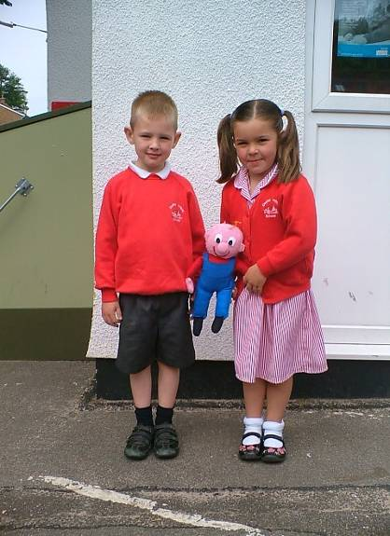

Attendance Data 2011/2012 Academic year
During the school year 2011/2012 KS1 had an attendance rate of 95%
The total number of Authorised absences 4.4%
Year 1 & Year 2 children only (122 children)
The total number of Unauthorised absences 0.35%
Year 1 & Year 2 children only (122 children)

Absence Procedures

If your child is unwell, please notify the office before 9:00 a.m. on the first day of absence. Attendance is closely monitored by the school. Holidays in term time will only be authorised in exceptional circumstances and this must be agreed personally with the head teacher at least 14 days in advance of the planned absence. Occasional days off for outings such as trips to a theatre with parents will not be authorised. All unauthorised absences have to be reported on the child’s annual report, to the Local Education Authority and Department of Education and Employment. Letters will be sent to parents of children whose attendance is a concern.

Regular attendance at school is very important. Absences can quickly disrupt a child’s sense of security and valuable learning time is lost.

Equally important is that your child arrives at school on time for registration. The beginning of the day provides opportunities for talking about the day's activities and, when a child is late, this can be disruptive to the child and the class. If you arrive in school later than 9.10 am your child will receive an unauthorised absence mark for the morning session. It is also extremely important for your child’s sense of security that you arrive to collect him/her from school at the correct time.

School Times: 8.55am to 3.05pm. Lunchtime lasts from 12.00 - 1.25 pm. Part-time children leave school at 12 noon. Children have a morning and afternoon playtime of 15 minutes.

Extended School Provision: Throughout the year, we offer a variety of activities including study support, sport, music, arts and crafts and other special interest clubs. Our Parent Information Contact Person, Mrs Julia Froude, is able to signpost parents to quality before and after school care as well as easy access to specialist services such as speech and language therapy.

Charging Policy
The governors, in accordance with guidelines issued by the L.A., have approved the following policy: -

“In order to comply with the 1988 Education Act all schools are required to provide without charge, all educational or extra-curricular activities taking place in school time. Therefore educational visits taken by individual classes or groups, visiting theatre performances or any activity that has hitherto been paid for by parents directly can no longer be charged. However, the schools’ budget cannot bear the cost of such activities and in future parents will be informed of the costing of such activities and will be invited to contribute towards their child’s participation. No child will be excluded because of parents’ inability to pay”.

Whilst there is no obligation for you to contribute to extra-curricular activities, the various activities may not take place if sufficient contributions have not been received. The Head teacher will deal with any individual queries regarding this policy.

Other Information
Parents wishing to see copies of the statements of the Local Education Authority school curriculum policy and aims, copies of Department of Education Orders and Circulars about the curriculum should contact the Head teacher.

The Next Stage
At the age of 7+ the children leave us for Junior School. Parents receive from the LEA a booklet outlining the process of choice and schools available. Most of our children go on to All Saints Junior School in Githa Road and transition is well planned between the two schools. Year 2 children experience numerous visits to All Saints in the months leading up to the summer holidays. The teaching staff of both schools liaise with regard to teaching methods, curriculum progression and pupil progress. The schools also benefit from shared In Service Training throughout the year. Year 3 teachers visit our children in their classes before the end of the summer term.

Admissions Criteria for Dudley Infant School.
Published admission number - 60

Parents may find it helpful to know that, if there are insufficient places available to meet demand, these will be allocated in accordance with the following list of priorities:

1) Children with strong medical or exceptional evidence which leads the Director of Education to conclude that attendance at any other school would be inappropriate, and looked after children;

2) Children who will have a brother or sister at the school at the time of admission;

3) Children who will have a brother or sister at our 'linked' junior school,
All Saints Junior School, Githa Road, Hastings.

4) Children living within a predefined community area, prioritised if necessary on the basis of the shortest route from home to school using surfaced, passable routes;

5) Children living outside the predefined community area, prioritised if necessary on the basis of the shortest route from home to school using surfaced, passable routes.

Please note that all preferences given by parents on their application form will be
considered equally by East Sussex Admission department. This means a second or third preference has equal status to a first preference. All stated preferences – first, second and third – for a school will now be considered against the admissions criteria for each school. Secondly, where a child qualifies for a place at more than one of the schools given on the form, the highest ranked preference school will be offered. Further information is on the East Sussex County Council webpage www.eastsussex.gov.uk/education. no change

affecting the arrangements before the start o
September 2013 to August 2014
Term | Start date | End date
School INSET day (East Sussex) | Tuesday 3 September 2013
School Term 1 (East Sussex) | Wednesday 4 September 2013 | Friday 25 October 2013
Autumn school holiday (East Sussex) | Monday 28 October 2013 | Friday 1 November 2013
School Term 2 (East Sussex) | Monday 4 November 2013 | Friday 20 December 2013
Christmas school holiday (East Sussex) | Monday 23 December 2013 | Friday 3 January 2014
School Term 3 (East Sussex) | Monday 6 January 2014 | Friday 14 February 2014
February school holiday (East Sussex) | Monday 17 February 2014 | Friday 21 February 2014
School Term 4 (East Sussex) | Monday 24 February 2014 | Friday 4 April 2014
Spring school holiday (East Sussex) | Monday 7 April 2014 | Thursday 17 April 2014
School Term 5 (East Sussex) | Tuesday 22 April 2014 | Friday 23 May 2014
May school holiday (East Sussex) | Tuesday 27 May 2014 | Friday 30 May 2014
School Term 6 (East Sussex) | Monday 2 June 2014 | Wednesday 23 July 2014

Please note that the teachers also have five In-Service Days when the school will be closed. We will notify you, as far in advance as possible, when an In-Service Day is arranged.

PRIVACY NOTICE

Dudley Infant School processes personal information about its pupils and is a ‘data controller’ for the purposes of the Data Protection Act 1998. We collect information from you and may receive information about you from your previous school.

We hold and use your information to support your teaching and learning, monitor and report on how well you are doing, provide you with pastoral care and to assess how well your school is doing.

The information we hold includes your contact details, national curriculum assessment results, attendance information, your ethnic group, special educational needs and any relevant medical information.

We will not give information about you to anyone outside the school without your permission unless the law and our rules permit it. We are required by law to pass some of your information to East Sussex County Council and to the Department for Education (DfE).

YOU CAN ASK TO SEE THE INFORMATION WE HOLD ABOUT YOU

If you want to see a copy of the information we hold and share about you then please contact
Mrs J Froude, School Administrator

If you need to know more about how East Sussex County Council and the DfE store and use your information please contact them:
East Sussex County Council: www.eastsussex.gov.uk/dataprotection

DfE: www.teachernet.gov.uk/management/ims/datamanagement/
privacynotices/pupilsdata/

www.teachernet.gov.uk/management/ims/datamanagement/
privacynotices/pupilsdata/thirdpartyorgs/

If you are unable to access these websites, please contact the County Council or the DfE as follows:
Information Governance Officer
Children’s Services
East Sussex County Council
County Hall
St Anne’s Crescent  01273 482901
Lewes  CS.DPA@eastsussex.gov.uk
BN7 1UE  www.eastsussex.gov.uk

Public Communications Unit
Department for Education
Sanctuary Buildings
Great Smith Street  0870 000 2288
London  info@education.gsi.gov.uk
SW1P 3BT  www.education.gov.uk

Attendance information is not collected for pupils under 5 years of age at Early Years Settings or maintained schools.

